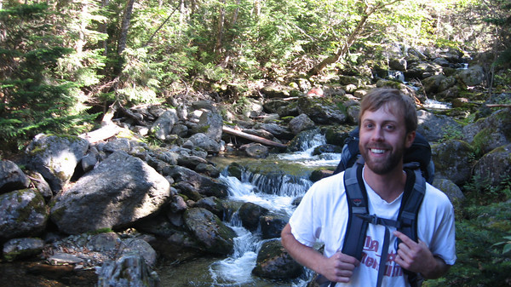

Dana Radcliffe Bio

My name is Dana Radcliffe and I teach 6th-grade Language Arts and Social Studies at Hamilton International Middle School in Seattle. I am extremely excited and honored to participate in the 2014 CE tour of China. As an international school, Hamilton‘s mission is to provide rigorous academics in an atmosphere that promotes world language and global perspectives. I teach Chinese history at Hamilton, but have never been to China or Taiwan. I applied to this program because I would like to incorporate firsthand knowledge of China to better inspire and educate my students on Chinese culture, history, and language, and its relationship to international and domestic topics. I also hope to foster collaborations among educators in my school and in surrounding schools concerning Chinese culture and history. Lastly, I hope this opportunity provides an avenue to build relationships with Chinese schools and schools in Seattle.

I was born in Tampa, Florida into a military family. Because of this, most my childhood was spent moving around. Through these experiences, I was able to travel and see other parts of the world at a young age. One of the most memorable events from this time period was that I was fortunate to live in Berlin during the fall of the Berlin Wall. This event and others as a child opened up a lot of doors for me. I think many of these early experiences account for my interest in learning about other cultures, traveling, and teaching humanities.

Most of my teenage years and adult life was spent in Virginia until a few years ago when I moved to Seattle. I graduated in 2002 with a Bachelor’s of Science in Geography from James Madison University. After graduation, I moved to Charlottesville, Virginia where I worked as an environmental consultant. Coincidently, this job allowed me to return to Germany and other parts of Europe often and reconnect with old friends and acquaintances, and keep my knowledge of the language and customs fresh.

After three years as a consultant I decided to pursue other interests in music and building. I spent the remaining four and a half years learning carpentry and stone masonry while I tried my hand as a keyboardist and guitarist. During this time, I was able to travel and perform as a musician throughout the United States. However, throughout all of these experiences, I had always thought about teaching. A number of experiences, including time working with a sister school program in El Salvador showed me how powerful education can be from a local and international perspective. I enrolled in a master’s program and graduated with a Master’s of Science in Education in 2012 from Old Dominion University. The program provided me with the option to complete my studies and student teaching here in Seattle and I jumped at the opportunity. It was a great choice; I have fallen in love with the PNW and the city of Seattle.

When I am not teaching I love to be outdoors or playing music. Camping, hiking, and backpacking are some of my favorite activities. I also enjoy biking and running. I currently coach track at Hamilton and teach music one night a week at Meter Music School in Seattle. I continue to write and perform when time allows. The majority of my family lives in Virginia. We are relatively small, but close knit. I have a brother who lives in Fredericksburg, Virginia and one nephew. He is eight years old, and a bundle of energy. I love traveling and have been fortunate to travel throughout the United States, Europe, and Latin America. However, I have never been to Asia. I am looking forward to a fun and thoughtful introduction with my other CE participants this summer!